Test Case: tc001_SPX_Dev5_Crear_Solicitud_Articulo_Almacen
Step 1 - Enter username and password and click to button Enter : Credentials Entered
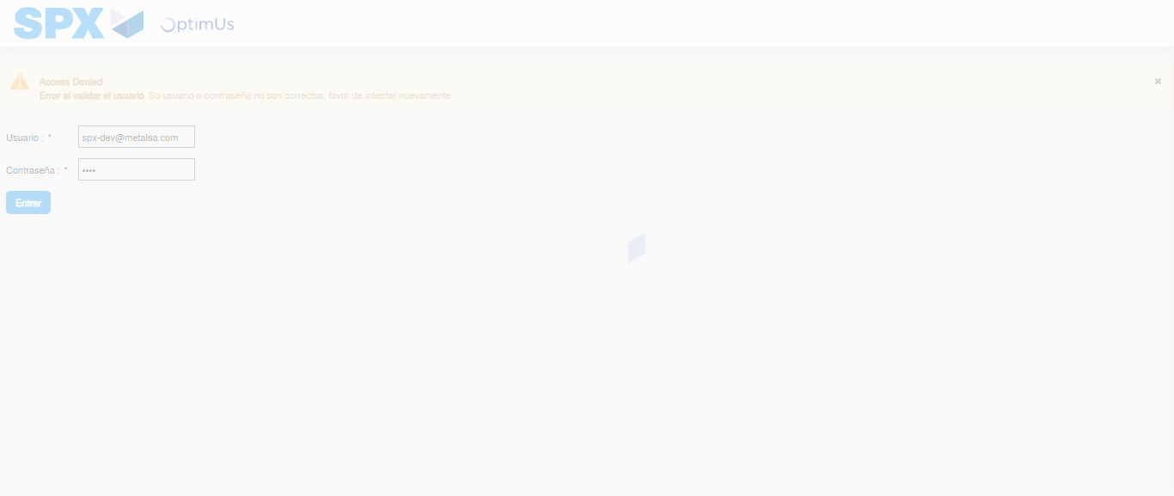Image file-name: QC_Testing-tc001_SPX_Dev5_Crear_Solicitud_Articulo_Almacen-1787939929957

Step 2 - Select to UEN and Access to Request for a New Inventory Item : UEN Correctly selected and Correct access
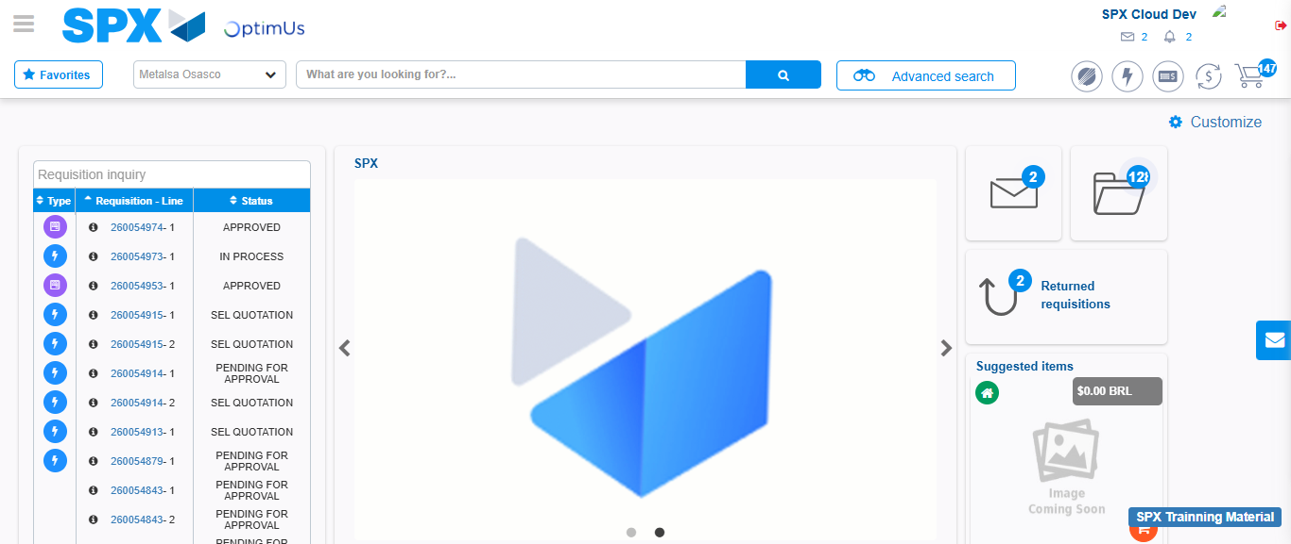Image file-name: QC_Testing-tc001_SPX_Dev5_Crear_Solicitud_Articulo_Almacen-1787940003700

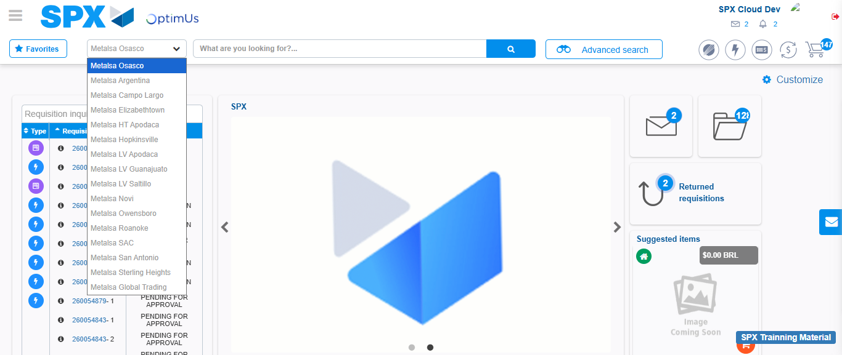Image file-name: QC_Testing-tc001_SPX_Dev5_Crear_Solicitud_Articulo_Almacen-1787940004154

Image file-name: QC_Testing-tc001_SPX_Dev5_Crear_Solicitud_Articulo_Almacen-1787940012955

Step 3 - Select options first section : Options seleted correctly
Image file-name: QC_Testing-tc001_SPX_Dev5_Crear_Solicitud_Articulo_Almacen-1787940013273

Image file-name: QC_Testing-tc001_SPX_Dev5_Crear_Solicitud_Articulo_Almacen-1787940013489

Step 4 - Select options at Screen: Options seleted correctly
Image file-name: QC_Testing-tc001_SPX_Dev5_Crear_Solicitud_Articulo_Almacen-1787940013273

Image file-name: QC_Testing-tc001_SPX_Dev5_Crear_Solicitud_Articulo_Almacen-1787940013489

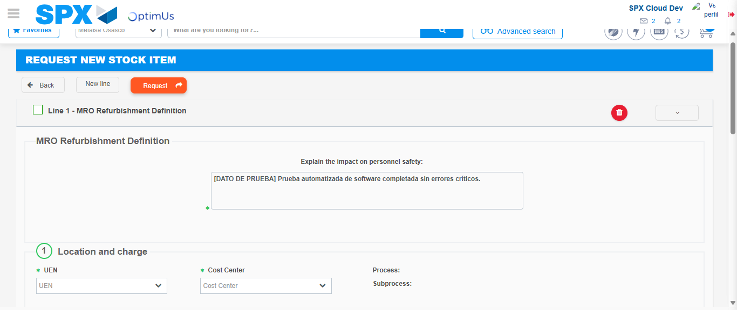Image file-name: QC_Testing-tc001_SPX_Dev5_Crear_Solicitud_Articulo_Almacen-1787940025789

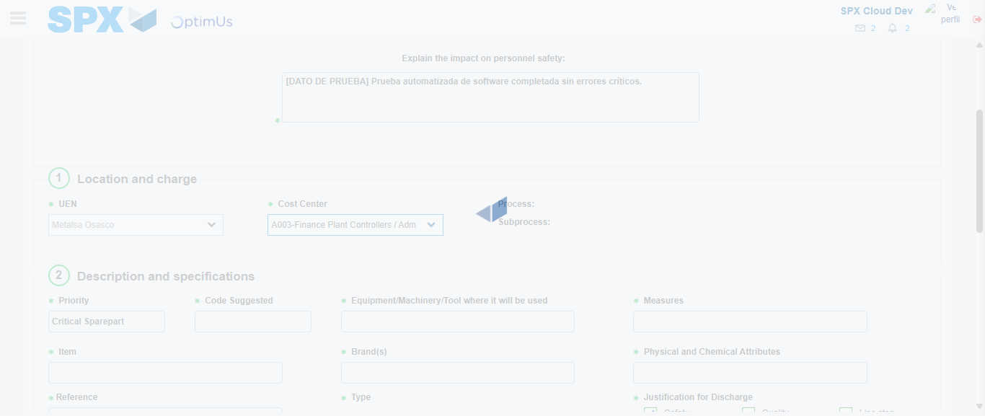Image file-name: QC_Testing-tc001_SPX_Dev5_Crear_Solicitud_Articulo_Almacen-1787940031352

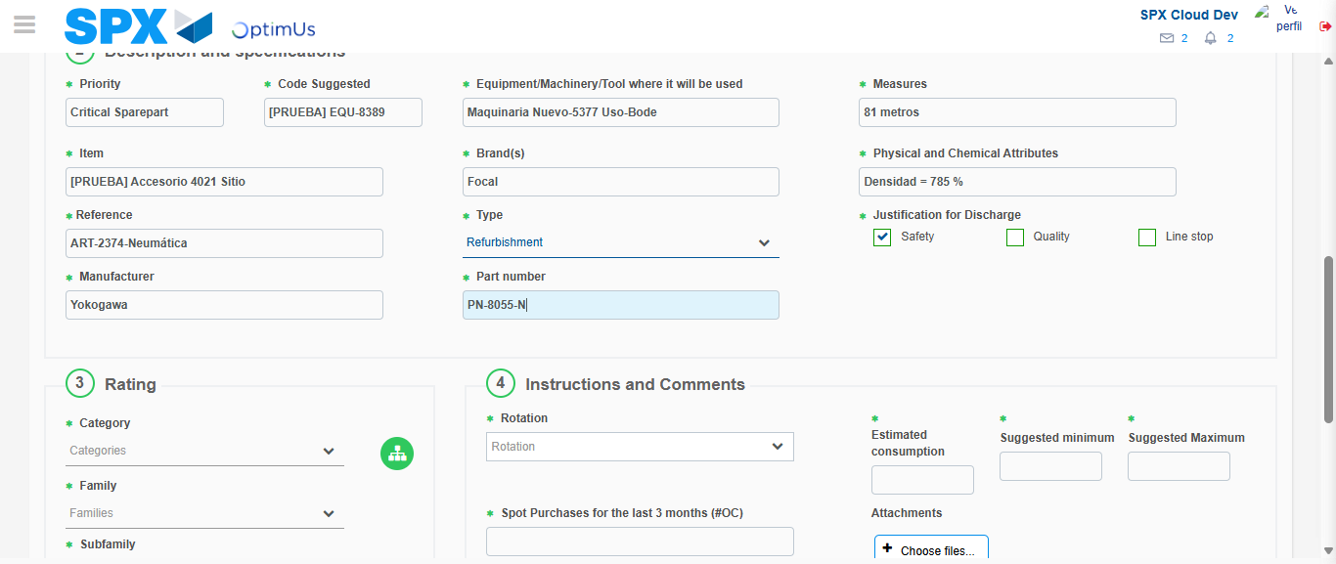Image file-name: QC_Testing-tc001_SPX_Dev5_Crear_Solicitud_Articulo_Almacen-1787940033220

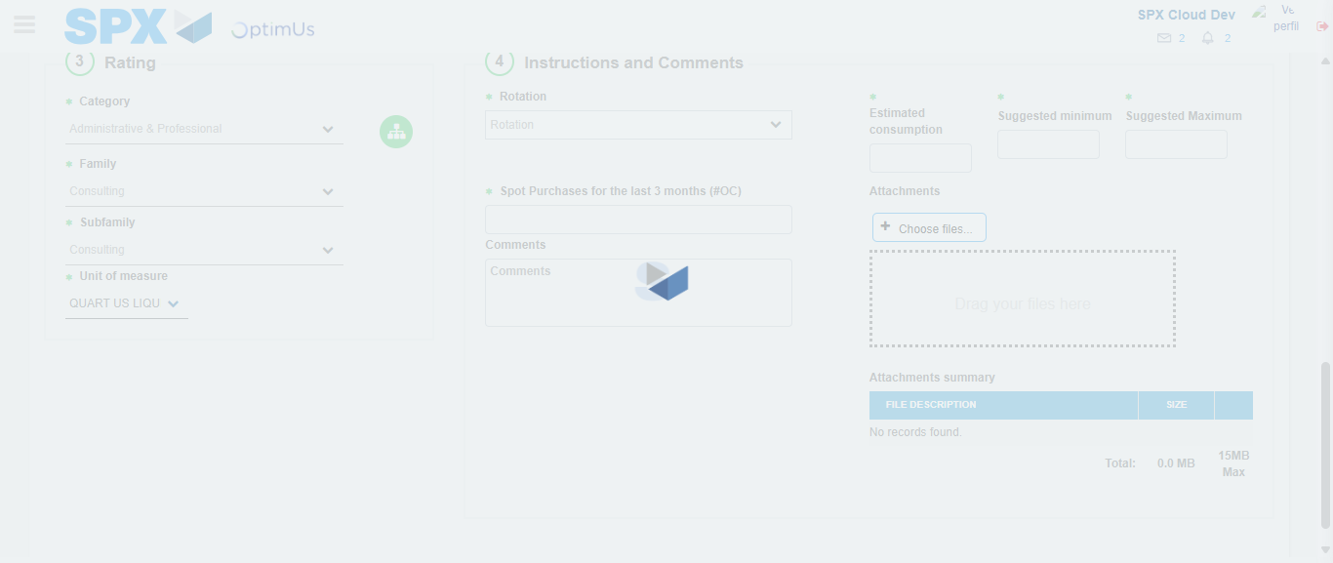Image file-name: QC_Testing-tc001_SPX_Dev5_Crear_Solicitud_Articulo_Almacen-1787940046979

Step 5 - Request New Item : Request Accepted
Image file-name: QC_Testing-tc001_SPX_Dev5_Crear_Solicitud_Articulo_Almacen-1787940003700

Image file-name: QC_Testing-tc001_SPX_Dev5_Crear_Solicitud_Articulo_Almacen-1787940004154

Image file-name: QC_Testing-tc001_SPX_Dev5_Crear_Solicitud_Articulo_Almacen-1787940012955

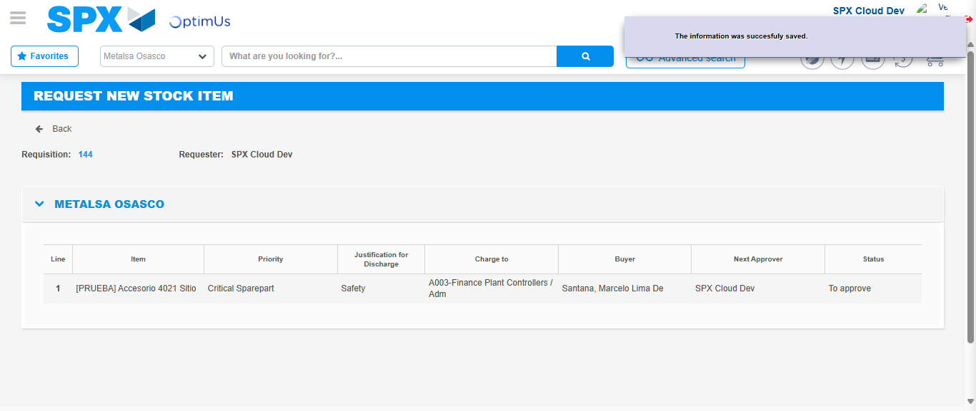Image file-name: QC_Testing-tc001_SPX_Dev5_Crear_Solicitud_Articulo_Almacen-1787940067245

Image file-name: QC_Testing-tc001_SPX_Dev5_Crear_Solicitud_Articulo_Almacen-1787940067454

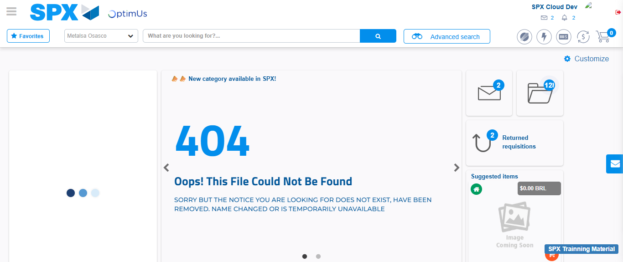Image file-name: QC_Testing-tc001_SPX_Dev5_Crear_Solicitud_Articulo_Almacen-1787940089297

Step 7 - Return to Main Page SPX : Return to Main Page SPX
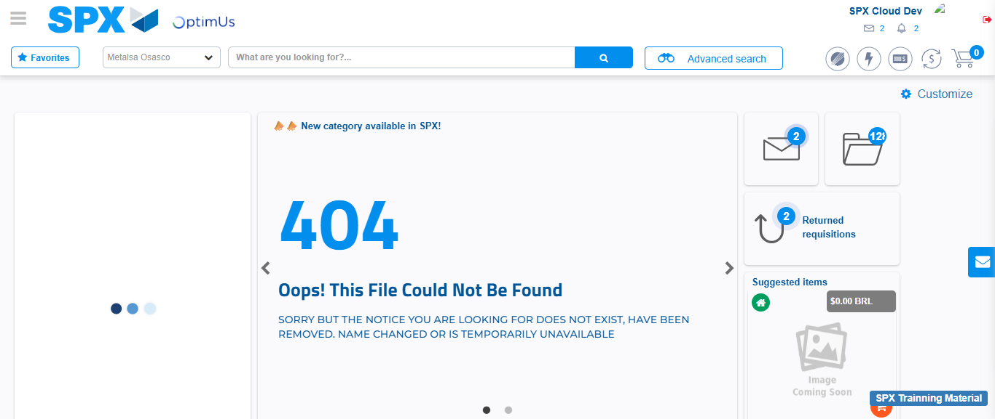Image file-name: QC_Testing-tc001_SPX_Dev5_Crear_Solicitud_Articulo_Almacen-1787940089638

